**Q1: -** Find out first_visit count and repeat_visit count of customers.

**Input: -**

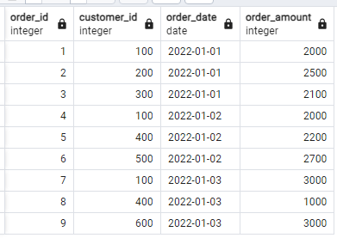

**Output: -**

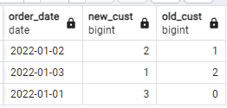

with cte as (select order_date,

case when order_date = min(order_date) over(partition by customer_id) then 1 else 0 end as first_visit,

case when order_date != min(order_date) over(partition by customer_id) then 1 else 0 end as old_visit

from customer_orders)

select order_date, sum(first_visit), sum(old_visit) from cte group by order_date;

**\*\*Bonus:** select * from employees fetch first 10 rows only;

**Q2: -** Find number of wins and losses

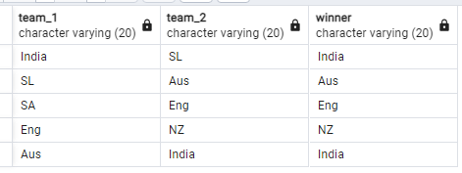**Input: - Output: -**

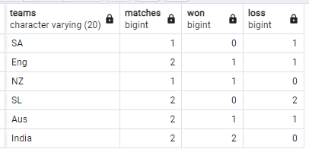

with cte as (select team_1 as teams, case when team_1 = winner then 1 else 0 end as win from icc_world_cup

union all

select team_2 as teams, case when team_2 = winner then 1 else 0 end as win from icc_world_cup)

select teams, count(*) as matches, sum(win) as win , count(*)-sum(win) as loss from cte group by teams

**Q3: -** Pivot without using function

**Input: -**

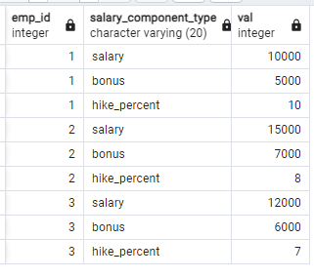

**Output: -**

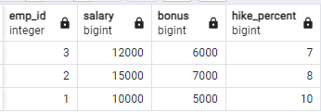

select emp_id,

sum (Case when salary_component_type = 'salary' then val end) as Salary,

sum (Case when salary_component_type = 'bonus' then val end) as bonus,

sum (Case when salary_component_type = 'hike_percent' then val end) as hike_percent

from emp_compensation

group by emp_id;

**Q4: -** Find duplicate row in a table

**Input: -**

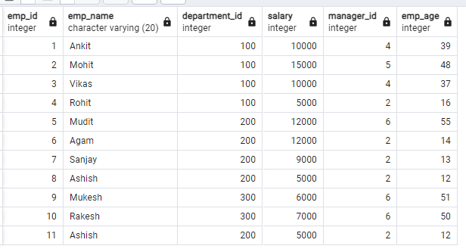

**Output:**

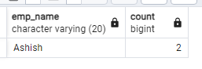

select emp_name, count (1) from emp1 group by emp_name having count (1)>1

**Q5: -** Delete Duplicate records

**Input: -** Same as above

**Output: -**

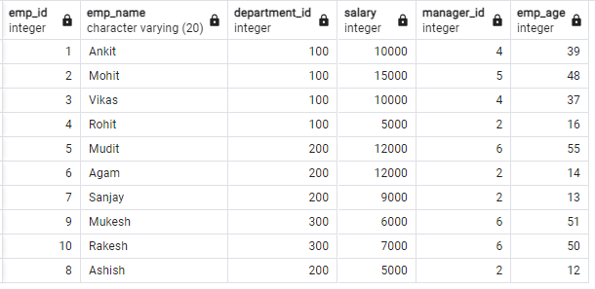

WITH cte AS (

SELECT emp_id, ROW_NUMBER () OVER (PARTITION BY emp_name, department_id ORDER BY emp_id) AS row_num FROM emp1

)

DELETE FROM emp1 WHERE emp_id

IN (SELECT emp_id FROM cte WHERE row_num > 1);

**Q6: -** Find theProduct(s) under budget of customers.

**Input: Output:**

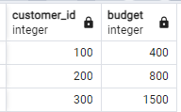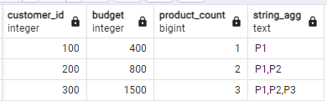 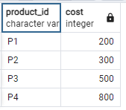

with running_cost as (

select *, sum(cost) over(order by cost asc) as r_cost -- would be diff when duplicate records(use rows between….)

from products

)

select c.*, count(1) product_count, STRING_AGG(r.product_id, ',')

from customer_budget c left join running_cost r

on r.r_cost < c.budget

group by customer_id, budget

order by 1

**Q7: -** Find second highest salary from each department

**Input: -**



**Output: -**

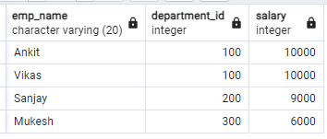

select emp_name, department_id, salary from (select *, dense_rank() over(partition by department_id order by salary desc) as dr from emp1) e where dr =2;

**Q8:** Find the emp whose salary is greater than it’s manager (self-join)

**Input: -**

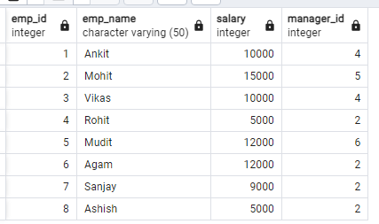

**Output: -**

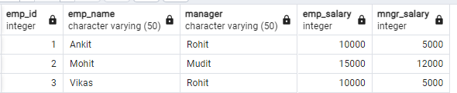

select e.emp_id,

e.emp_name,

m.emp_name as manager,

e.salary as emp_salary,

m.salary as mngr_salary

from emp_manager e

inner join emp_manager m on e.manager_id = m.emp_id

where e.salary >m.salary;

**Q9: -** Tricky question on Joins. Find records of all 4 joins of below 2 tables.

**T1: T2:**

**Id Id**

1 1

1 2

NULLNULL

NULL

**Answer:**

Left: 3

Inner: 2

Right: 5

Outer: 6

**Q10: - Find** mode of given column**.**

**Input: -**

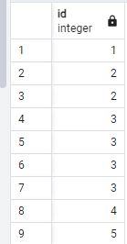

**Output:-**

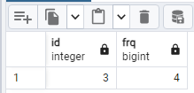

with cte as

(select id, count (1) frq from mode group by id)

select * from cte where frq = (select max(frq) from cte);

**Q11: -** Running Sum

**Input: -**

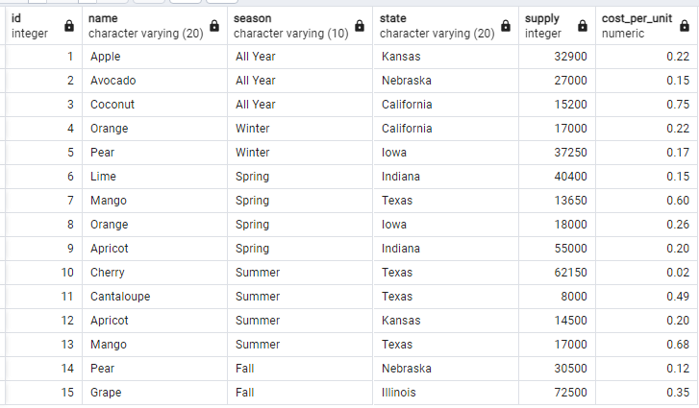**Output: -**

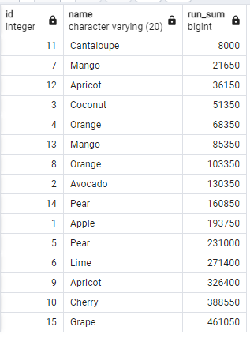

select id, name, sum(supply)

over (order by supply rows between unbounded preceding and current row) as run_sum

from fruit_imports;

**Other example:** sum(supply) over (order by supply rows between 2 preceding and 3 following row)

**Q12: -** Find Player who won gold but not silver and bronze.

**Input: -**

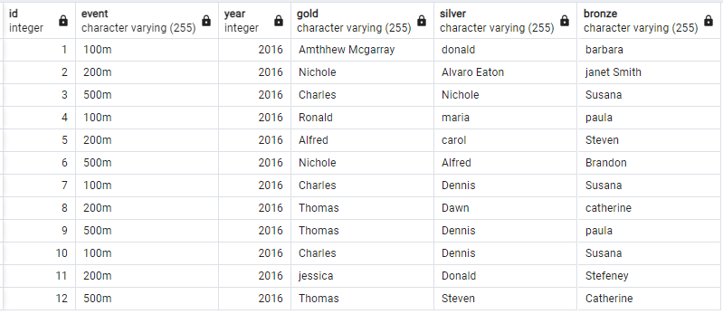**Output: -**

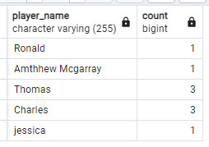

select gold as player_name, count(*) from events where gold not in (

select silver from events union all

select bronze from events)

group by player_name

**Q13: -** Find business days between created date and resolved date of tickets by excluding weekends and public holidays.

**Input: -**

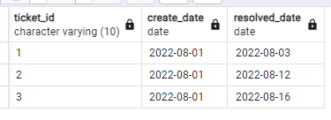**Output: -**

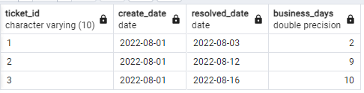

SELECT ticket_id, create_date, resolved_date

, (resolved_date - create_date) - 2*round ((resolved_date - create_date)/7) - count(holiday_date) as business_days

FROM tickets left join holidays on holiday_date between create_date and resolved_date

and trim (TO_CHAR (holiday_date, 'Day'))!= 'Sunday' and trim (TO_CHAR (holiday_date, 'Day'))!= 'Saturday'

group by ticket_id, create_date, resolved_date order by ticket_id;

**Q14: -** Find emp who is present inside the hospital.

**Input: -**

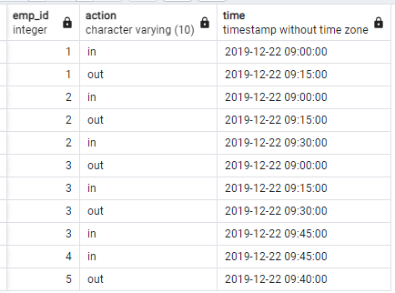**Output: -**

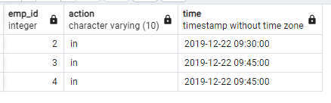

with cte as (

select *, rank() over (partition by emp_id order by time desc) rnk

from hospital )

SELECT emp_id, action, time FROM cte where rnk=1 and action='in';

**Q15: -** find most searched room type and count.

**Input: -**

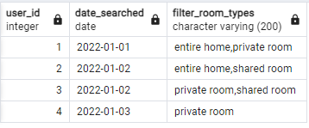**Output: -**

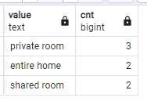

with room as

(select sum (case when filter_room_types like '%entire%' then 1 else 0 end) as eh,

sum (case when filter_room_types like '%private%' then 1 else 0 end) as pr,

sum (case when filter_room_types like '%shared%' then 1 else 0 end) as sh from airbnb_searches)

select 'entire home' as value,eh cnt from room

union all select 'private room', pr from room

union all select 'shared room', sh from room order by cnt desc;

**or with String_Split(SSMS): -**

select value as room_type, count (1) as no_of_seraches from airbnb_searches

cross apply string_split(filter_rooms_type,’,’)

group by value

order by no_of_seraches desc;

**Q16: -** Find all emp whose salary is same in same dept.

**Input: -**

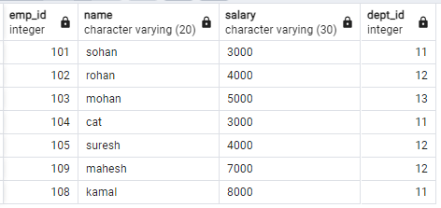

**Output: -**

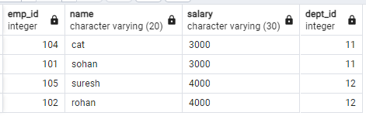

select a.emp_id,a.name,a.salary,a.dept_id from emp_salary a

inner join emp_salary b

on a.dept_id=b.dept_id and a.emp_id<>b.emp_id

where a.salary=b.salary

order by a.dept_id;

**OR**

WITH cte AS (

SELECT *,

COUNT(*) OVER (PARTITION BY dept_id, salary) num_same_sal

FROM emp_salary)

SELECT *

FROM cte

WHERE num_same_sal > 1

**Q17: -** Find unmatching records like below

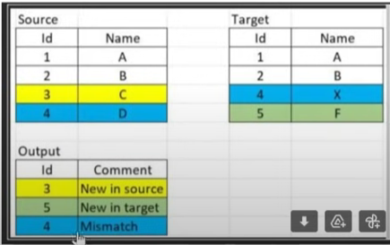

SELECT COALESCE([a.id](javascript:void(0);), b.id) AS id,

CASE WHEN [a.name](javascript:void(0);) IS NULL THEN 'New in target'

WHEN [b.name](javascript:void(0);) IS NULL THEN 'New in Source' ELSE 'Mismatch' END AS comment

FROM source AS a FULL OUTER JOIN target AS b ON [a.id](javascript:void(0);) = [b.id](javascript:void(0);)

WHERE [a.Name](javascript:void(0);) <> [b.Name](javascript:void(0);) OR [a.id](javascript:void(0);) IS NULL or [b.id](javascript:void(0);) IS NULL;

**Q18: -** Find min and max salary from each department.

**Input:**

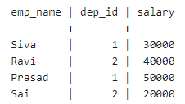 **Output:**

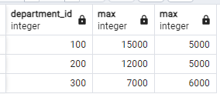

with cte as (select department_id,

case when salary = max(salary) over(partition by department_id) then salary end as max_sal,

case when salary = min(salary) over(partition by department_id) then salary end as min_sal

from emp1)

select department_id, max(max_sal), max(min_sal) from cte group by department_id

**Q19:** Categories the low, avg and high salary including 0 count.

**Input:**

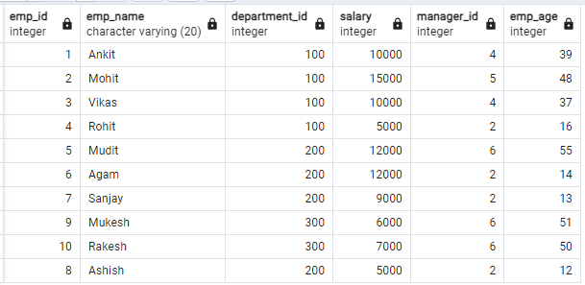**Output:**

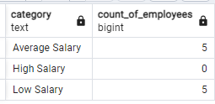

with salarycategories as (

select

case

when salary < 10000 then 'low salary'

when salary >= 10000 and salary < 30000 then 'average salary'

when salary >= 30000 then 'high salary' end as category

from emp1),

categorylist as (

select 'low salary' as category

union all

select 'average salary' as category

union all

select 'high salary' as category

)

select cl.category, count(sc.category) as count_of_employees

from categorylist cl

left join salarycategories sc on cl.category = sc.category

group by cl.category;

**Q20: -** find the number of days between each user’s first post of the year and last post of the year in the year 2021

**Input:**

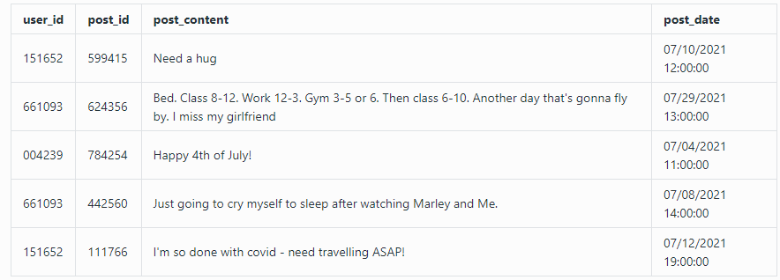

**Output:**

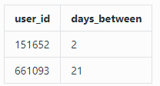

select user_id, max(post_date::DATE) - min(post_date::DATE)

from posts where date_part('year', post_date)='2021'

group by user_id having count(1)>=2;

**Q21: -** Write a query to retrieve the average star rating for each product, grouped by month. The output should display the month as a numerical value, product ID, and average star rating rounded to two decimal places. Sort the output first by month and then by product ID.

**Input:**

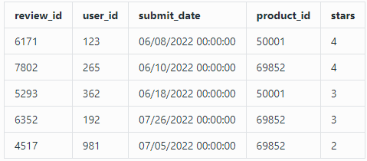**Output:**

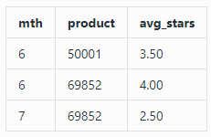

SELECT EXTRACT (MONTH FROM submit_date) AS mth,

product_id, ROUND (AVG (stars), 2) AS avg_stars

FROM reviews

GROUP BY EXTRACT (MONTH FROM submit_date), product_id

ORDER BY mth, product_id;

**Q22: -** Find unique queries histogram including 0.

**Input:**

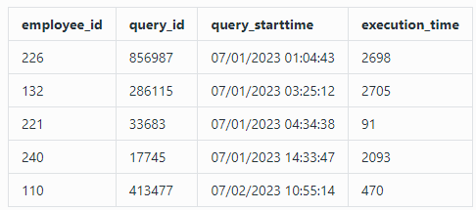 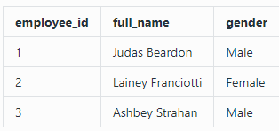

**Output: -**

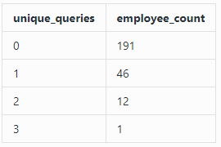

with query_count as (

select e.employee_id,

coalesce(count(distinct q.query_id),0) as unique_queries

from employees e

left join queries q

on e.employee_id = q.employee_id

and extract(month from q.query_starttime) >= 7

and extract(month from q.query_starttime) < 10

group by e.employee_id

)

select

unique_queries, count(employee_id) as employee_count

from query_count

group by unique_queries

order by unique_queries

**Q23: -** Make the password from name and hiredate

select first_name,length(first_name) as count_char,

LOWER(SUBSTRING(first_name FROM 1 FOR 4)) || TO_CHAR(hire_date, ‘ddmm’) AS password

from employees;

**Q24: -** Find max, min populated cities in every state.

**Input:**

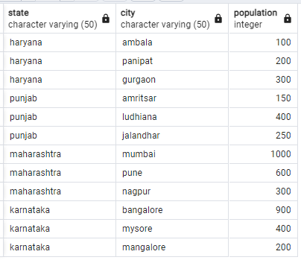**Output:**

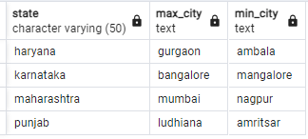

with cte as (

select state

, case when population = max(population) over(partition by state) then city end as max_city

, case when population = min(population) over(partition by state) then city end as min_city

from city_population)

select state, max(max_city) as max_city, max(min_city) as min_city

from cte

group by state;

**Q25:** - Find name of the credit card, and how many cards were issued in its launch month. Order the results starting from the biggest issued amount.

**Input:**

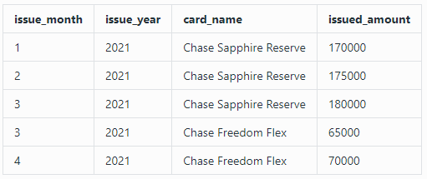**Output:**

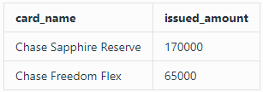

with cte as

(SELECT card_name,issued_amount, issue_month || '-' || issue_year as issue_date,

Min (issue_month || '-' || issue_year) over (partition by card_name) as launch_date

from monthly_cards_issued)

select card_name, issued_amount

from cte where issue_date = launch_date

order by issued_amount desc;

**Q26: - Explain Index**

In SQL, an index is a database object that improves the speed of data retrieval operations on a table by creating a data structure that allows for faster searching, sorting, and filtering. It works like an index in a book, enabling quick access to the desired data without scanning the entire table. However, indexes can slow down data modification operations like INSERT, UPDATE, and DELETE because the index also needs to be updated.

CREATE INDEX idx_customer_name ON customers (last_name, first_name);

DROP INDEX idx_customer_name ON customers;

**Type:**

• Unique Index

• Composite Index

• Full-Text Index

• Clustered Index

• Non-Clustered Index

• Bitmap Index

• Filtered Index

• Hash Index

A **clustered index** organizes the actual data rows in the table to match the order of the indexed column(s). Think of it like a library where books (rows) are physically arranged on the shelves in alphabetical order by title (indexed column). Because of this, there can only be one clustered index per table, as you can’t physically arrange the books in more than one way.

In contrast, a **non-clustered index** is like having an index card in a catalog that lists the book title (indexed column) and points you to the specific shelf and spot where the book is stored. The books (data rows) remain in their original order on the shelves, separate from the order defined by the non-clustered index.

**Q27: -** Calculate the 3-day rolling average of tweets for each user. Output the user ID, tweet date, and rolling averages rounded to 2 decimal places.

**Input: -**

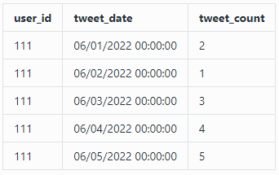**Output: -**

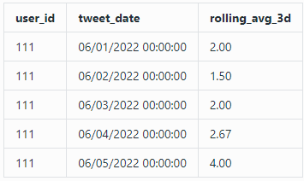

SELECT user_id, tweet_date, round (AVG (tweet_count)

over(partition by user_id order by tweet_date rows BETWEEN 2 PRECEDING and current row),2) as rolling_avg_3d from tweets;

**Q28: -** Write a query to identify the top two highest-grossing products within each category in the year 2022.

**Input: -**

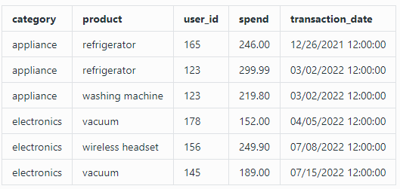

**Output: -**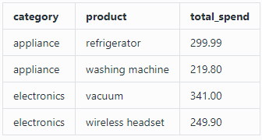

with ranked_spending_cte as (

select category, product,

sum(spend) as total_spend, rank() over (partition by category order by sum(spend) desc) as ranking

from product_spend

where extract (year from transaction_date) = 2022

group by category, product)

select category, product, total_spend

from ranked_spending_cte

where ranking <= 2

order by category, ranking;

**Q29: -** Coalesce example

select employee_id, first_name, last_name,

coalesce (email, phone, 'no contact info') as contact_info from empl;

**Q30: -** Example of lead and lag

select employee_id, first_name, salary,

lag (salary, 1) over (order by salary) as previous_salary,

lead (salary, 1) over (order by salary) as next_salary

from employees;

**Q31: -** Find the user_id and page_id not liked by himself but friends liked it.

**Input:** **Output:**

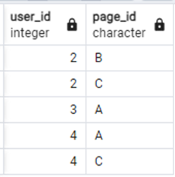 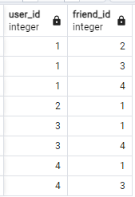 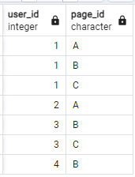

with cte as (

select f.user_id, l.page_id from likes l

join friends f on f.friend_id = l.user_id

)

select * from cte except (select * from likes)

order by 1,2;

**Q32:**  Find products which sale got increased every year.

**Input:**

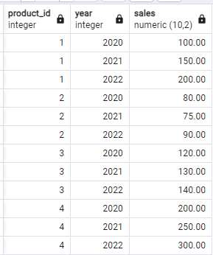 **Output:**

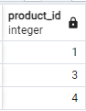

with cte as (

select product_id, year, sales,

lag(sales) over (partition by product_id order by year) as previous_sales

from sales_data

)

select product_id

from cte

group by product_id

having min(case when previous_sales is not null then

case when sales > previous_sales then 1 else 0 end

else 1 end) = 1;